Gibbs Farm Summer Day Camps 2021
June 2021 Update
Camp Guidelines – Covid-related information will be bolded.
What time should we arrive for Check In?
Check in will be outside of the white admissions building beginning at 8:50am for all camps starting at 9:00am. Check In for PeeWees Camp starts at 9:15. During Check In you will need to provide the name of the person picking your child up that day. For the 2021 season, camp check-in will take place outside the white admissions building. More information regarding the logistics of check-in will be emailed to you a few days in advance of the camp start date.
During the week of camp, parents should use the CDC’s Covid-19 self checker each day to monitor their child for symptoms of Covid-19. Restated questions are reproduced below and can also be found in full on the CDC website (https://www.cdc.gov/coronavirus/2019-ncov/symptoms-testing/symptoms.html ). If “yes” is the answer to any of the questions, the camper will be unable to attend camp and the camp registration will be refunded for the camp days missed.
If your camper or someone in the camper’s household develops symptoms of Covid-19 between days of camp, please call the Gibbs Farm office (651-646-8629) or email gibbs@rchs.com ASAP so that other camps families and Gibbs Farm staff can be informed.
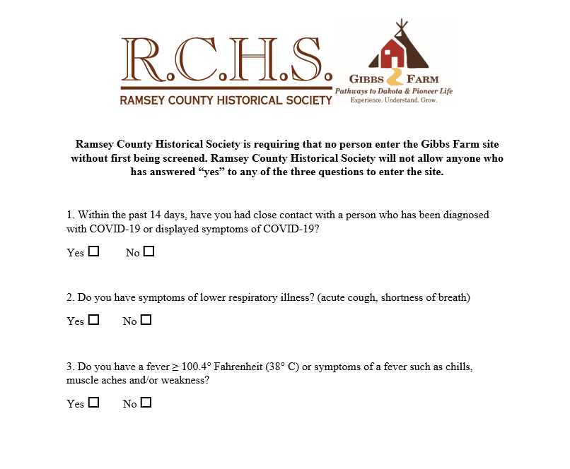
What does my child need to bring?
A bagged lunch, water bottle and comfortable, weather appropriate clothing. Please make sure that your child’s belongings are labeled. We donate lost and found items at the end of the season. All campers will be required to bring a facemask. Per CDC guidelines we will not be allowing face or mouth shields. Facemasks will be required while indoors. Attachments that allow the mask to be worn around the neck are highly encouraged to help campers keep track of it.
There will be several opportunities throughout the day for outdoor, socially distant activities that will act as group “mask breaks.” Campers will also be encouraged to take personal mask breaks as necessary in the same manner of bathroom breaks. The camper will inform their leader that they need a short mask break and can move away from the group (while staying within eyesight) and remove their mask and when ready will place the mask back on their face and rejoin the group.
Children will be socially distant while eating lunch (when masks cannot be worn).
Please note: If there is an excessive heat concern, facemask guidelines may be altered.

Can my child sign up for camp with a friend?
Yes! Each parent can sign up their child up via our online registration. This year campers will be put into groups prior to the start of camp. If your child wants to be in the same group as their friend attending camp, please include a note in your camp registration. Note: this year, camp group sizes will be limited to 5 children per group.

What is your photo sharing policy?
We love to share pictures and videos of campers having fun at Gibbs Farm! We use these photos and videos on social media, our website, advertisements, and signage. We will never disclose your child’s name, age, or other identifying information. Feel free to opt out on the camp registration form.

Can my child wear a costume?
Children are welcome to wear costumes that allow them to fully participate in active outdoor (and sometimes messy) activities. Please make sure that costumes are culturally respectful.

What if my child has special medical needs?
Please contact us if your child has any special medical needs you would like us to know about. Staff will do everything we can to ensure your child has a safe and enjoyable camp experience.

What if there is bad weather?
Camp goes on rain or shine, as most activities can be brought inside. There is enough sheltered space for all campers in case of sudden severe weather. If Gibbs Farm Staff determines that programs cannot be run safely because of forecasted severe weather, parents and guardians will be notified before the start of camp. The limited capacity of camps this year will allow us to hold camp activities indoors and socially distant in the event of inclement weather.

Who is leading the camps?
Day camps are led by our fantastic seasonal interpretive staff. All staff members have received training and passed a background check. Students in our Youth Intern Program help with most of our camps, these student volunteers assist staff in making sure camp runs smoothly. All staff members and Youth Volunteers will be masked and use the same guidelines as those for campers (see above). Camp groups we be “cohorts” and will be led by the same staff member and same Youth Volunteer each day of camp. Staff may remove their masks during lunch, but will remain socially distant from the campers in their charge. Staff and volunteers will complete a health screening check in accordance with CDC guidelines each day before camp start.

Open Houses
This year, we will not be hosting open houses on the last day of camp. On Thursdays campers will be picked up at the regular camp end time.

Can I register at last minute?
Registration for camp is closed when the camp is full or two days before it starts. After that time, you will not be able to register online, call the Gibbs Farm office at 651-646-8629 to check availability. Due to the reduced capacity of camps, we expect to sell out quickly. We will wait list up to 3 campers in the event that a registration is cancelled. You will be informed that you are on the active waitlist and if a registration slot opens up.

What is the Cancellation Policy?
Three weeks’ notice is required to receive a refund. Unless there is an available registration slot, we will we be unable to switch your registration to a later session. If camps are cancelled due to Covid-related restrictions or executive orders, camps registrations will be automatically refunded. Please call our office at 651-646-8629 to cancel a registration.

Applicable for PeeWees Camp:
How does registration work?
Pioneer PeeWees camp is offered on Wednesdays and Fridays throughout the summer. Each day is a different topic and an independent session, feel free to sign up for as many as you wish.
Do I attend camp with my child?
Nope, Pioneer Peewees Camp is just for kids! However, we understand your child might time to adjust before participating in an independent activity. You know what is best for your child, some parents might stay for the welcome song, or read a book under a tree in the distance during the first session.
Does my child need to be potty trained?
Yes, all children attending Pioneer PeeWees camp should be potty trained.
Snack?
We provide a snack during each session of Pioneer Peewees. Snack usually consists of a juice box or water with fruit/veggies and a small cookie. We will take water breaks as well, especially if it is a hot day. During snack time (when facemasks cannot be worn), PeeWees will be socially distant.

Our guidelines are based on the following and are subject to change
when new recommendations are issued:
https://www.cdc.gov/coronavirus/2019-ncov/community/schools-childcare/summer-camps.html
https://www.health.state.mn.us/diseases/coronavirus/youthguide.pdf

Have another question? Contact us!
Phone: 651-646-8629
Email: gibbs@rchs.com
Website: https://www.rchs.com/gibbs-farm/day-camps/
Follow us!
Instagram: Gibbsfarm_mn
Facebook: GibbsfarmMN
